**Frisbee**

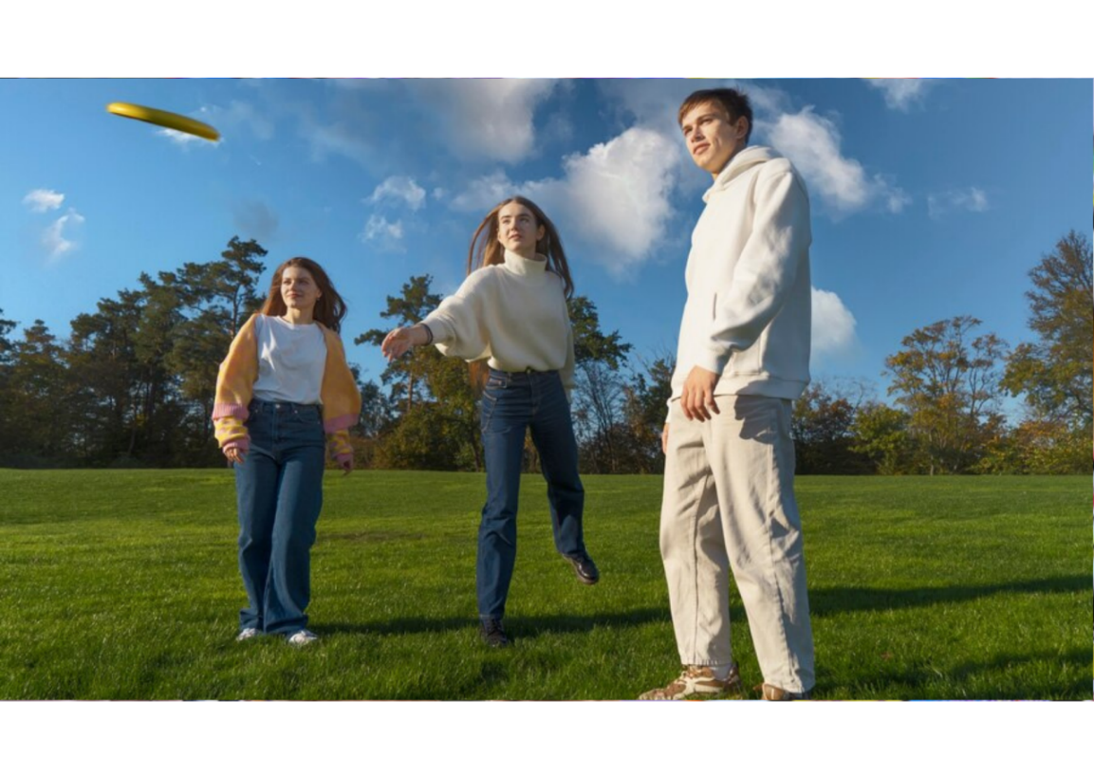

**Description**: Players throw a flying disc to each other, often incorporating different throwing techniques and games.

**How to Play**: Players take turns throwing the disc to each other. Variations include Ultimate Frisbee, where teams score points by catching the disc in the opponent's end zone.

**Location**: Park, beach.

**Things Needed**: Flying disc.

**Players**: 2 or more.